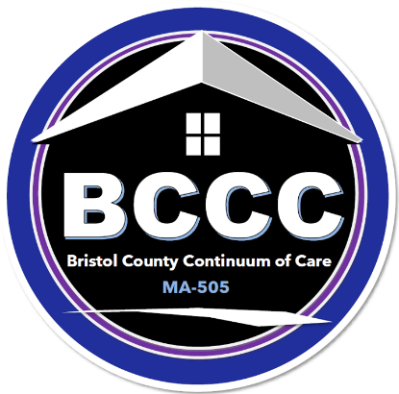
MA-505 Bristol County Continuum of Care
Membership Agreement.2025

Bristol County coordinates a comprehensive response to homelessness using a “Continuum of Care” (CoC) approach through its Bristol County Continuum of Care or “BCCC.”.

The BCCC is a broad community-based coalition of homeless providers, allied resources and community partners reflecting the diversity of the county’s cities and towns and regularly meeting to strategically address the complexity of homelessness and make sure individuals and families have access to housing that is appropriate, sustainable safe, decent and affordable. It is committed to the concept that each person is entitled to live in dignity and is focused on the elimination of homelessness within its geography.

The BCCC advocates on behalf of individuals and families experiencing homelessness to improve access to housing and housing stability. In so doing it strives to:
- improve the availability of housing and supportive resources,
- competitively seek and secure diverse funding for shelter, housing and supports,
- provide a meaningful forum for those with lived experience to contribute to solution-building,
- maintain robust data through a homelessness management information system (HMIS),
- ensure strategic decision-making is the product of an equitable lens and
- evaluate and modify systems and practices to meet complex and changing needs within the continuum and beyond. All of this is done to strategically lift individuals and families out of homelessness through a compassionate CoC.

This signed pledge of commitment to participate in the BCCC and its acceptance by the Executive Board serves as the basis of membership in the BCCC.

Active membership allows member organizations and those with lived experience a voice in the decision-making progress for issues brought before the BCCC including, but not limited to, the identification of homeless needs and the prioritization of projects for the annual Continuum of Care application. Active membership also allows access to federal homelessness funds from the U.S. Department of Housing and Urban Development administered by the City of New Bedford’s Office of Housing & Community Development (OHCD).

The BCCC meets the third Thursday of every month either in person at a location to be determined, via ZOOM platform or as a hybrid of both.

All are welcome to attend, join and participate.

Please print agency/org/indiv name:

Executive Director/CEO Name if applicable:

Address: City:

State/Zip:

Contact Name: Phone:

Contact Email:

As a member of the Bristol County CoC, the member agrees to:
- Abide by the BCCC Code of Conduct,
- Support all BCCC members in their efforts to provide housing, resources and services to those experiencing homelessness,
- Share resources and ideas for potential speakers and relevant topics for BCCC meetings.
www.nbhspn.com
https://www.bristolcountycoc.com

All BCCC non-profit member organizations are eligible to apply for any funds that may become available; final eligibility depends on satisfactorily meeting the required conditions of any funding offered.

Signature: _____________________________________________Date: 1/10/2025

Please Email Completed Forms to: Jennifer.Clarke@newbedford-ma.gov

