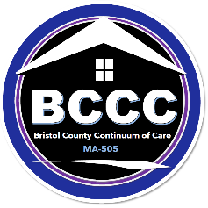
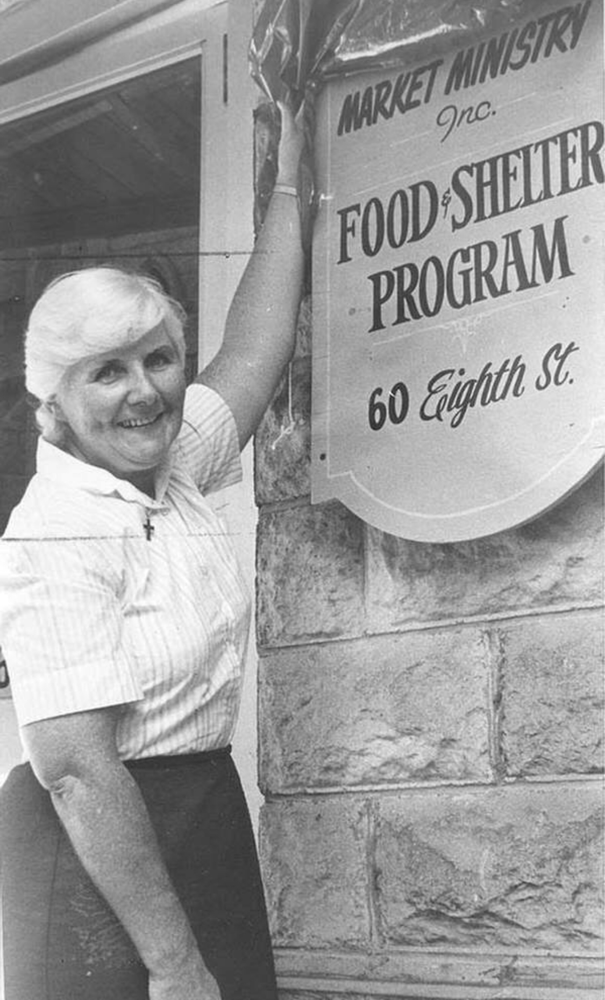
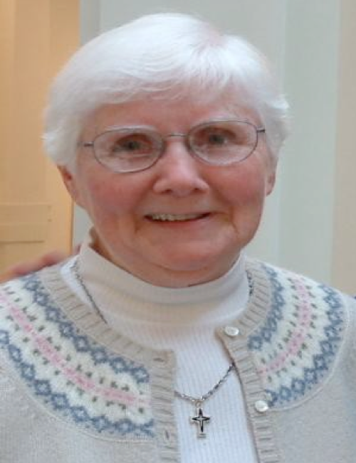
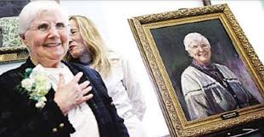

SISTER ROSE
2024 HOMELESS COMMUNITY LEADERSHIP AWARD

The Bristol County Continuum of Care (BCCC) is now accepting nominations for the 20th Annual Sister Rose Homeless Community Leadership Award. This award will recognize an outstanding current or former member of the MA-505 CoC or member agency staff in the Greater New Bedford area. Applications for the Sister Rose Award are available at upon request at Jennifer.Clarke@newbedford-ma.gov.

The Sister Rose Award is an annual award named in honor of its first recipient, Sister Rose Ellen Gallogly, former Executive Director of Market Ministries (renamed Sister Rose House) and one of the founding members of the HSPN, the former New Bedford Continuum of Care. The award is given annually to an individual from within the Greater New Bedford area in recognition of his or her achievement, dedication and compassion in his or her personal and professional life in living out the mission of the BCCC that is rooted in the belief that every person is entitled to live in dignity.

QUALIFICATIONS
A nominee must be a current or previously involved member of the Bristol County Continuum of Care in the Greater New Bedford area, either as an individual or by virtue of the organization’s or agency’s membership where the individual is employed. It is a prestigious award given to one who has made a significant impact within the community over a long period of time with respect to homelessness.

Deadline for nominations is Friday, December 20, 2024

JUDGING
Evaluation and decisions will be made by the nomination committee comprised of the previous Sister Rose Award recipients:

2011 Steve Montembault
2012 Bruce Morell
2013 Carl Alves
2014 Russ Chamberlain
2015 Peter Muise
2016 George Bailey
2017 The Rev. David Lima

2018 Raymond Duarte
2019 Wendy Bluis
2020 Danielle Brown
2021 Patrick Sullivan
2022 Darlene Spencer
2023 Cynthia Wallquist

2005 Sister Rose Ellen Gallogly
2006 Arlene McNamee
2007 Kathleen Schedler Clark
2008 Fred Macedo
2009 Shelly Correia
2010 Brenda Souza

HISTORY
Sister Rose Ellen Gallogly, known as “Sister Rose” to all, began her service to the City of New Bedford in the 1960s at Saint Hedwig’s Church and the Regina Pacis Center, working primarily with the Hispanic community. In the 1970’s she began work as an Adjustment Counselor for the New Bedford Public Schools where she met the first of her several foster children. Sister Rose maintained a relationship with her first foster child for over 30 years, later enjoying the addition of foster grandchildren.

In 1982 Sr. Rose joined a group of clergy and community members in operating the soup kitchen at the Pilgrim United Church of Christ then formed Market Ministries, Inc., a non-profit organization with the mission to serve the basic needs of the homeless and hungry of Greater New Bedford with food, shelter, compassionate support, providing each with a safe haven where guests found physical and emotional sustenance to improve their lives.

The first shelter site opened at 1204 Purchase St. on February 11, 1983 in the middle of a major snowstorm and its first two guests were two men huddled in an alley outside the shelter. In June of 1984 the shelter moved to 60 Eighth Street and provided shelter to 25-32 guests each night. In 2010 Catholic Social Services began oversight/administration of Market Ministries and moved the operation to its Division Street location where the shelter exists today, renamed the Sister Rose House in acknowledgement of the tremendous work and dedication of its founder. Today’s Sister Rose House continues this important work honoring those in greatest need.

SISTER ROSE
2024 HOMELESS COMMUNITY LEADERSHIP AWARD
NOMINATION FORM

This form is in a fillable format. Please complete the form and submit it no later than Friday, December 20, 2024 at 12 noon to Jennifer Clarke at Jennifer.Clarke@newbedford-ma.gov. All nominations must be received by the deadline and all questions must be answered in order to be considered complete and eligible for consideration.
Who are you nominating?

Nominee: Affiliated BCCC Agency/Organization/Other
Located in Greater New Bedford:

Address:

Phone: Email:

Affiliated BCCC Organization for whom the nominee works/volunteers:

Nominee biography

Provide some background information about the person whom you’re nominating and their lifetime of service. (You may use an additional sheet if needed).

Briefly identify their performance and accomplishments as a community leader over the years serving those experiencing homelessness.

Please describe your nominee’s impact on the organization and community and how he/she has made a real and significant difference over the years. (You may use an additional sheet if needed).

Other information that will help us understand why this person should be presented with this honor.

Who is making this nomination?

Nominator’s Name: BCCC Organization:

Address:

Telephone: Email:

